LCEL is a changing concept in lang chain, helps to put all the logics into one component using | pipe symbol

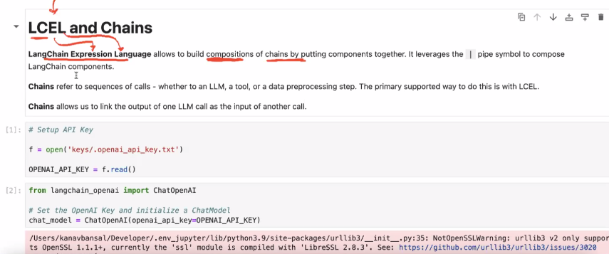

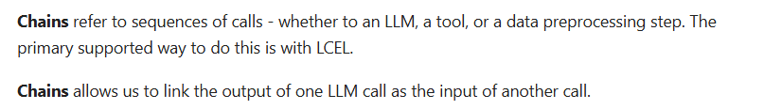

**Difference between stream and invoke**

1. Stream – It prints response like the chat gpt website in line by line, and it doesn’t take more time as the invoke take
2. Invoke – prints response once whole response it generated successfully

**EX:**

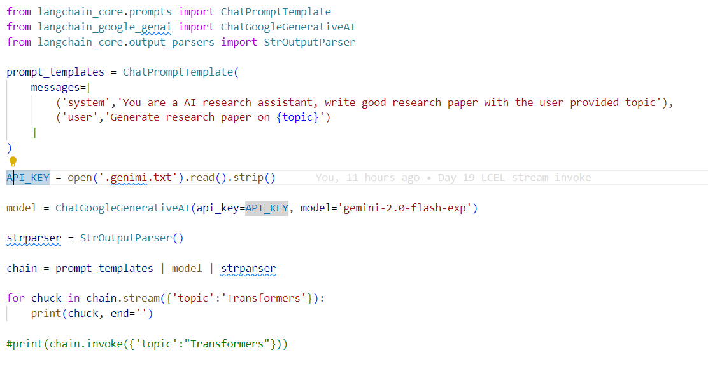

**VISULIZE CHAIN**

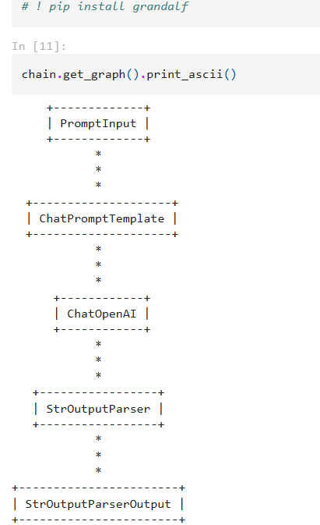

**USE OF TEMPERATURE**

